Day 1 Practice Sheet — Excel Formulas & IF Function
Module: Excel for Data Analysis — Formulas & IF
Prepared By: Mr. Akarsh/Dr. Ravneet Kaur
Objective: Practise SUM, AVERAGE, COUNT, COUNTA, MIN, MAX, IF and nested IF on a sales dataset.
SAMPLE DATASET
Use the sample data table below for all questions. The table shows Order ID, Salesperson, City, Product, Quantity, Unit Price, and Total Sales.
ORD-001 | Amit Sharma | Delhi | Laptop | 2 | 45000
ORD-002 | Priya Singh | Mumbai | Mobile | 5 | 18000
ORD-003 | Rahul Verma | Chennai | Tablet | 3 | 22000
ORD-004 | Neha Gupta | Pune | Laptop | 1 | 45000
ORD-005 | Amit Sharma | Delhi | Mobile | 4 | 18000
ORD-006 | Priya Singh | Mumbai | Laptop | 2 | 45000
ORD-007 | Rohit Jain | Jaipur | Tablet | 6 | 22000
ORD-008 | Neha Gupta | Pune | Mobile | 3 | 18000
ORD-009 | Rahul Verma | Chennai | Laptop | 1 | 45000
Order ID Salesperson City Product Quantity Unit Price Total Sales
ORD-010 Rohit Jain Jaipur Mobile 2 18000
PRACTICE QUESTIONS
Question | Task Description | Your Answer / Code
Q1 [SUM] | In cell G2, write a formula to calculate Total Sales for ORD-001. Copy it down to G11. Total Sales = Quantity × Unit Price. | 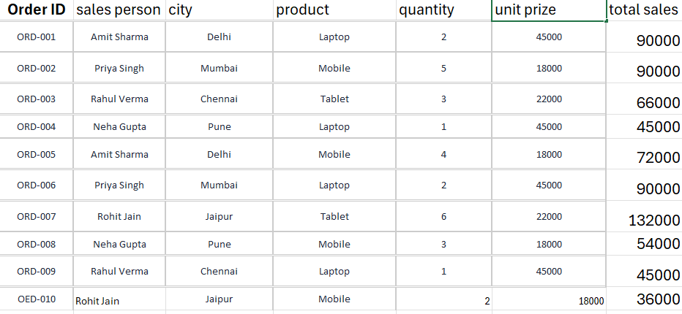
Q2 [SUM] | In a new cell below the table, calculate the Grand Total of all sales using SUM. | 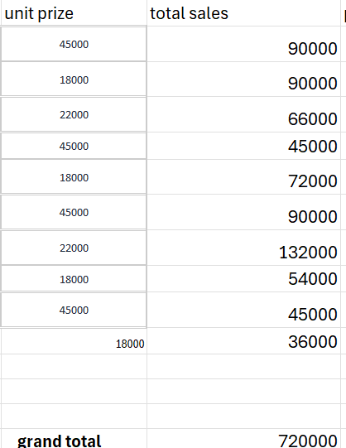
Q3 [AVERAGE] | Calculate the Average Order Value across all 10 orders using AVERAGE on the Total Sales column. | 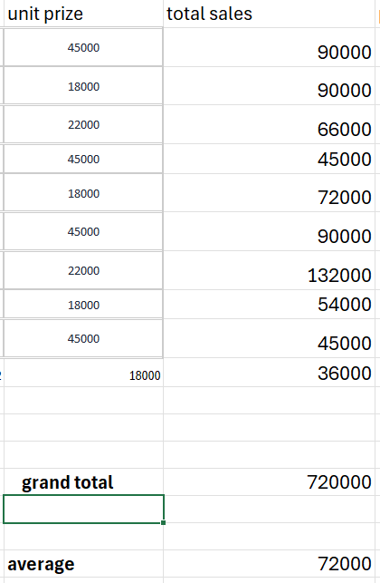
Q4  [COUNT/CO UNTA] | Use COUNT on the Quantity column. Then use COUNTA on the Salesperson column. Are the results the same? Why? | 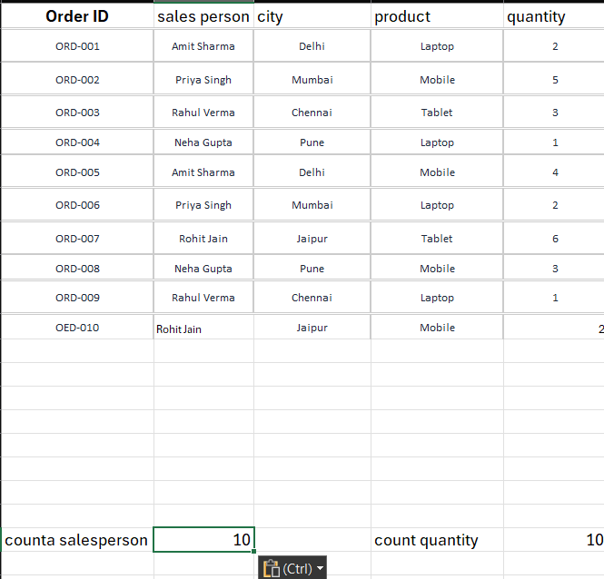
Q5 [MIN/MAX] | Find the Minimum and Maximum values in the Unit Price column. | 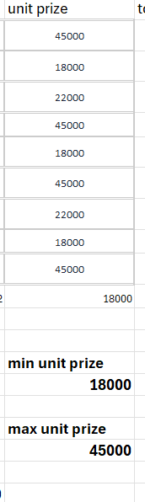
Q6 [MIN/MAX] | Which order had the highest Total Sales? Write MAX and note the Order ID manually. | 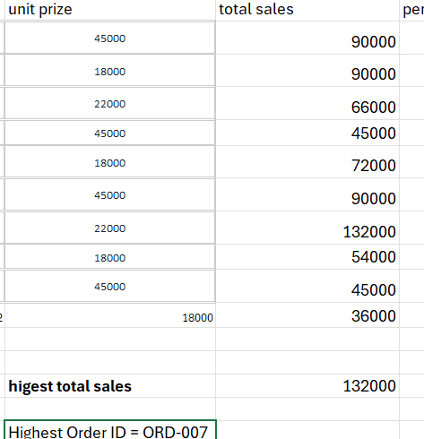
Q7 [IF] | In a new column called 'Performance', write an IF formula: if Total Sales > 80000 then 'High', else 'Low'. | 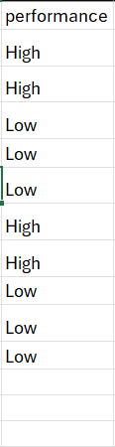
Q8 [IF] | In a new column called 'City Category', write IF: if City = 'Delhi' or 'Mumbai' then 'Metro' else 'Non-Metro'. Hint: use IF with OR(). | 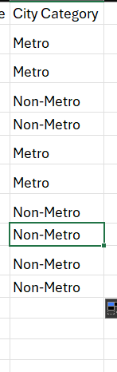
Q9 [Nested  IF] | In a new column called 'Commission Rate', write a nested IF: Total Sales > 100000 → 10%; Total Sales > 50000 → 7%; else 5%. | 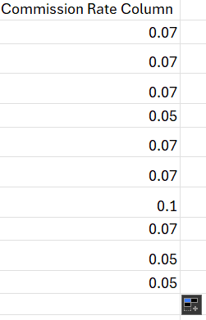
Q10 [Nested  IF] | Add a column 'Commission Amount' = Total Sales × Commission Rate. Then use SUM to find total commission payout. | 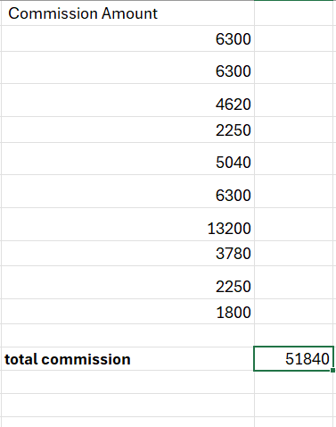
BONUS | Highlight all cells in 'Performance' column where value is 'High' using Conditional Formatting (Home → Conditional Formatting → Highlight Cells). | 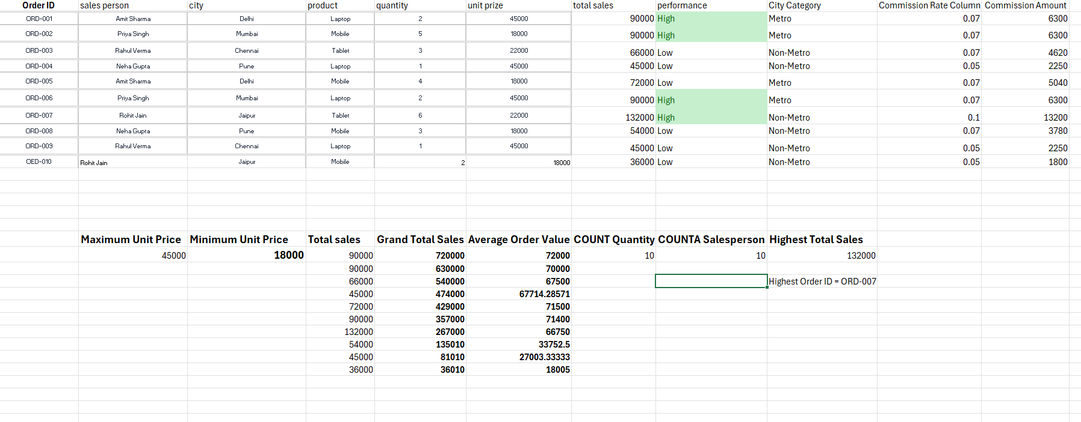
Day 1 Practice Sheet · Module: Excel for Data Analysis — Formulas & IF . Data Science Training Program

